We are carrying out maintenance works at Palmersgill Sewer Pumping Station, Eaglesfield

**Important Scottish Water Information**

Address 1  
Address 2  
Town  
Postcode

X 2025

What we are doing

We will be carrying out essential maintenance work at a sewer pumping station at Eaglesfield, Dumfries & Galloway. The pumping station requires new pumps, pipework and a panel.

The road through Eaglesfield will be closed just before the access road to Springkell House. Traffic will be diverted by Waterbeck on the B722.

|  |
| --- |
| When are we doing it |

Work is due to start Monday 5th May for up to 5 days

|  |
| --- |
| What happens next |

* Road closure through Eaglesfield before the access road to Springkell House
* We ask road users to follow signs for local diversion routes. Diversion signs will remain in place overnight
* There will be an increase in construction traffic for the duration of the works while materials are brought to site
* Due to limited space, tankers and vehicles will be parked at the side of the road to allow materials to be brought to site (new pipework, valves, and pumps)
* We will try and expedite the work as much as we can to allow the road to be opened earlier

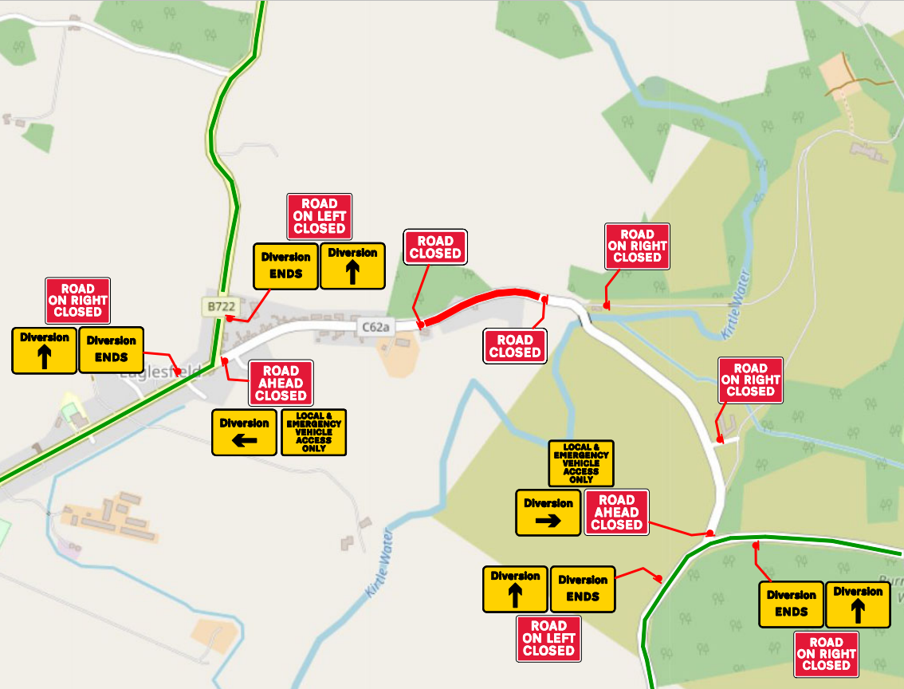

Traffic diverted by Waterbeck on the B722

Thank you for your patience and understanding while we complete this essential work. Please see below for details of how to keep up to date with what we are doing in your area.

Gavin McGlasson

E&M Technical Support Adviser