28th August 2024

Project reference
DV2/533363/McDonald Road

Our delivery partner, Morrison Water Services will be carrying out this work on our behalf.
Taking care of the wastewater network in McDonald Road, Edinburgh.

What are we doing
The final phase of the works at McDonald Road pumping station located in Broughton Primary School car park will be commencing in September 2024 with an expected completion of early 2025.
The final phase will consist of the removal and replacement of the foul screw located adjacent to the new storm screw within the pumping station, commissioning and reinstatement of the car park.
Initial preparation works are required prior to the removal of the screw which will consist of a road closure on Bellevue Road.

When are we doing it
We will be closing Bellevue Road from the junction of McDonald Road to 127 Bellevue Road on Monday 9th September 2024 for approximately 5 days. (Please see location map overleaf.)
What happens next
The main work area and compound are already established and access to the school and nursery maintained via the pathway. Site hoarding has been installed around the perimeter of the works area.
Works will consist of further clearing and rehabilitation works, upgrade and renewal of auxiliary equipment for the installation of the new screw.
Residents should expect to see an increase in site activity and delivery of plant to allow us to carry out these works safely. There may be, in some instances a requirement to work during the weekends.
There will be some disruption from construction traffic and noise during the works, however our contractor will work to try and keep this to a minimum where possible.
To ensure safety and to prevent traffic congestion of heavy goods vehicles accessing the site, vehicles accessing the area will be controlled by a site banksman.

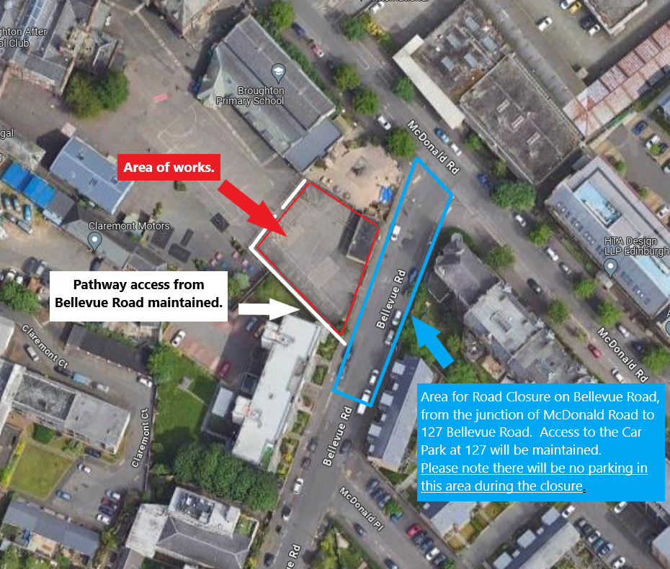

Map source: Google Imagery 2024, Airbus, Map data
We appreciate your patience and understanding whilst we carry out this essential work.
Yours faithfully

Customer Team
Morrison Water Services – Project DV2

