Important Scottish Water Information
Address 1
Address 2
Town
Postcode

Date
Taking care of your sewer network in Motherwell
Project reference
Capital/522765/GeorgeLeslie

Our delivery partner George Leslie will
be carrying out this work on our behalf.

What we are doing
We are taking care of the waste water services in your community by upgrading the sewer network and require to close Annan Glade periodically to complete the works safely.
When are we doing it
Work will start in Annan Glade on Mon 7 April and last approx. five weeks.
What happens next

- Your water supply and drainage services from your kitchen and bathroom should not be affected by our work.
- There will be a road closure during certain hours of the day (see overleaf) during the dates above. This will include the restrictions on vehicle access and parking restrictions during those hours of the day. There will be no weekend road closure required.
- Pedestrian access to properties and footpaths will remain in place.
- During the work you may notice some noise from construction equipment.

Thank you for your patience and understanding while we complete this essential work.

Mark MacLaren
Communication Manager

For illustrative purposes only:
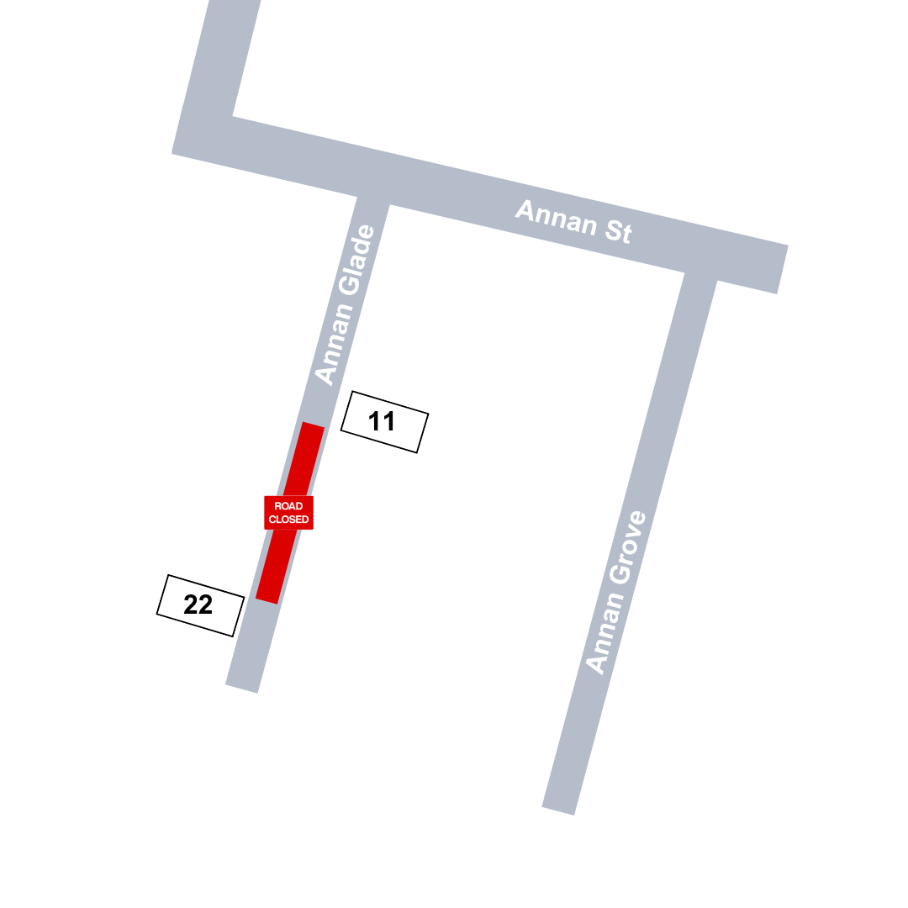
Annan Glade Closed
Monday – Friday

0915 - 1200
1330 - 1445
1530 - 1730

